**Mensuration Concepts**

Mensuration is a measurement concept. Standard and nonstandard units of measurement can be used to measure objects or amounts.

We have units for measuring length, weight, and capacity such as kilometre, metre, kilogramme, milligram, litre, millilitre, and so on.

Listed below are the different Mensuration concepts:

1. [2D shapes](https://www.placementpreparation.io/quantitative-aptitude/mensuration/concepts/#2d-shapes)
2. [3D shapes](https://www.placementpreparation.io/quantitative-aptitude/mensuration/concepts/#3d-shapes)

### 2D Shapes

2D shapes are plane objects that are entirely flat and have just two dimensions - length and breadth - in geometry.

They have no thickness and can only be measured in two dimensions. So we just have perimeters and areas for these designs, and there will be no volume since it lacks the third dimension.

### 3D Shapes

A three-dimensional shape with faces, edges, and vertices is known as a 3D shape. They have a surface area that comprises all of their faces. The volume of these forms is determined by the space they occupy. 3D shapes include the cube, cuboid, cone, and cylinder. As a result, these objects will have both area and volume measurements.

**Important Expressions**

### 1. Area (A)

### 2. Perimeter (P)

### 3. Volume (V)

### 4. Curved Surface Area (CSA)

### 5. Total Surface Area (TSA)

### 6. Square Unit

### 7. Cube Unit

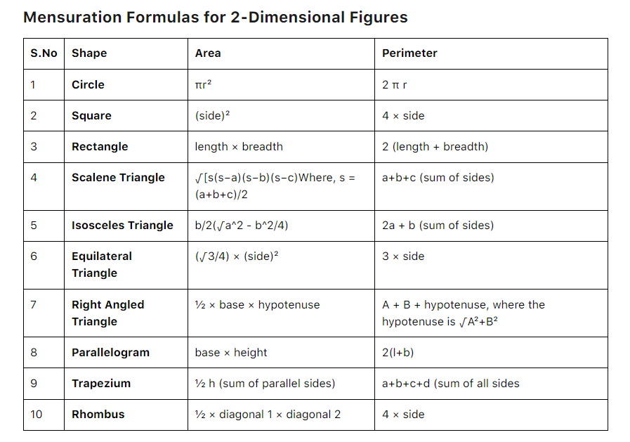

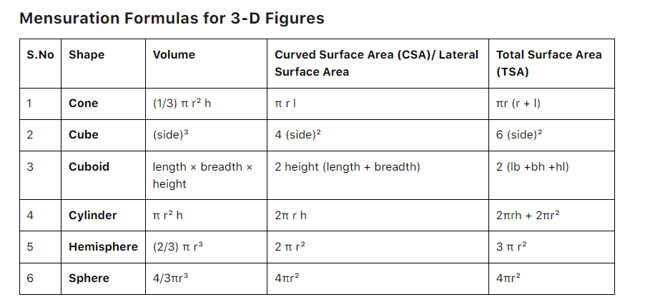

Q1 What is the area of an equilateral triangle of side 16 cm?

A 48√3 sq.cm

B 128√3 sq.cm

C 96√3 sq.cm

D 64√3 sq.cm

Q2 If the sides of a triangle are 26 cm, 24 cm and 10 cm, what is its area?

A 120sq.cm

B 130 sq.cm

C 312 sq.cm

D 315 sq.cm

Q3 The perimeter of a triangle is 28 cm and the inradius of the triangle is 2.5 cm. What is the area of the triangle?

A 35 sq.cm

B 42 sq.cm

C 49 sq.cm

D 70 sq.cm

Q4 Find the area of trapezium whose parallel sides are 20 cm and 18 cm long, and the distance between them is 15 cm.

A 225 sq.cm

B 275 sq.cm

C 285 sq.cm

D 315 sq.cm

Q5 Find the area of a parallelogram with base 24 cm and height 16 cm.

A 262 sq.cm

B 384 sq.cm

C 192 sq.cm

D 131 sq.cm

Q6 The ratio of the length and the breadth of a rectangle is 4 : 3 and the area of the rectangle is 6912 sq cm. Find the ratio of the breadth and the area of the rectangle?

A 1 : 96

B 1 : 48

C 1 : 84

D 1 : 68

Q7 A wire in the form of a circle of radius 3.5 m is bent in the form of a rectangle, whose length and breadth are in the ratio of 6 : 5. What is the area of the rectangle?

A 60 sq.cm

B 30 sq.cm

C 45 sq.cm

D 15 sq.cm

Q8 A cube of side one meter length is cut into small cubes of side 10 cm each. How many such small cubes can be obtained?

A 10

B 100

C 1000

D 10000

Q9 The radius of a wheel is 22.4 cm. What is the distance covered by the wheel in making 500 revolutions?

A 252 m

B 704 m

C 352 m

D 808 m

Q10 The ratio of the volumes of two cubes is 729 : 1331. What is the ratio of their total surface areas

A 81 : 121

B 9 : 11

C 729 : 1331

D 27 : 121